Systems Programming Practical

Introduction
For this practical we had to get familiar with multi-threading and use our knowledge of strings in C to make a chain of 10 processes, where each parent process would send a string to a child process using a pipe. The child process would swap to letters before itself making a child process and piping the changed string to its child.

Design

Part 1
First the commandline arguments are combined into one string for simplicity as it is much easier to manipulate one long string as opposed to (for example) 4 or five longer ones.
An iterative design was implemented as it seemed simpler to understand and implement conceptually.

Implementation

Part 1
The while loop only terminates when 10 processes have been made (i.e. count becomes greater than 10) or when a process has forked already (i.e. when the child_id variable == 0, as the new number will be the pid of its child process).
As the same pipe is reused between processes the unused ends in a particular process weren’t closed, as when that child process became a parent it would end up using the part of the pipe that was just closed beforehand.
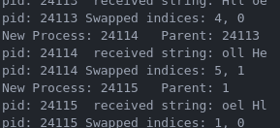
The parent_id variable stores the pid of the process just before it forks and becomes a parent. The getppid() function isn’t used because there is a chance that the parent process finishes before that line of code runs, and thus the pid 1 is given (signifying a zombie process).

